Langton Green Local History

Notes on Northfields and Paveys
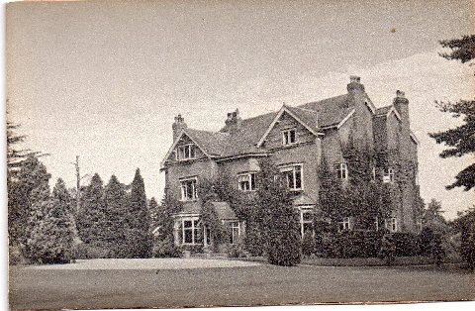
At the beginning of WW2 the imminent threat of invasion led KCC to purchase Northfields*, a Victorian house on Langton Road in Langton Green, as a Maternity Home for mothers from East Kent to have their babies in the comparative safety of West Kent. KCC also purchased Paveys*, another private house, on Speldhurst Road, Langton Green as a waiting location. A little while before expected delivery the mothers came to live at Paveys, and then were transferred to Northfields for the actual delivery.
Northfields was up a short drive but screened by a high hedge from the main road (now the A264), along which buses to and from Tunbridge Wells passed, and remained somewhat unknown by Langton people because it was not used by them. The medical regime at the time required mothers to remain in bed for some ten days after the birth before returning home.
After the war Northfields became more generally used and was transferred as a Maternity Home into the NHS when that started on 5 July 1948. It was later sold and demolished, and a Colt cedar house was built on the site, owned by a Mr and Mrs Bell. This has been extended over the years.
The attached photo has been confirmed as being of Northfields by Tom Douglas, the son of Rev R H Douglas, Vicar of Langton Green from 1919 to 1959, who lived in Northfields Lodge in the Bell's time. He claims that he transferred a bow window from the demolished Northfields to the Lodge, where it still is.
Family history enquiries to Langton Green Village Society are sometimes confused because there is a road in Speldhurst called Northfields which has misled the enquirer.

* If searching on Google maps postcodes TN3 0JN for Paveys and TN3 0DN for Northfield House may help to give APPROXIMATE locations.

